Presentation Materials for A Simulated Teaming and Scheduling Activity to Prepare Pre-Service or In-service Teachers to be Effective Teaming Participants
Google Link: https://drive.google.com/folderview?id=0B0QaMFYTfBrwQjB3dGhsUWdxUlE&usp=sharing

QR Code: Names with Grades Worksheet QR Code: Presentation Slides
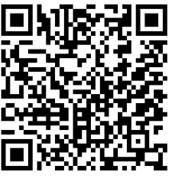

QR Code: Planning Cycle Worksheet QR Code: Block Plan
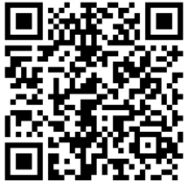
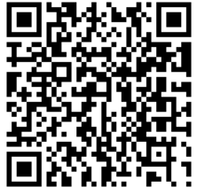

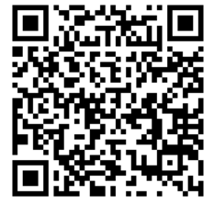
QR Code: Team Building Worksheet QR Code: Presentation Ex.

